Notes 2.8
Vocabulary: When you make a conclusion based on several examples, you are using inductive reasoning. When you make a conclusion based on statements that are assumed or have been shown to be true, you are using deductive reasoning.
Example: Inductive Reasoning
While shopping at a mall, you notice that the first three stores you visit are having a sale. You conclude that every store in the mall is having a sale.
Example: Deductive Reasoning
You have a rectangular garden. Two of your fences are at right angles. Since rectangles always have right angles, you conclude that the other angles are right angles.
Vocabulary: Conjectures
Conclusions reached from inductive reasoning can be true or false, and are called conjectures. A conjecture is a statement that is believed to be true but not yet shown to be true.
A bear is probably in the back of the cave. (Perhaps we really don’t want to investigate and prove that it’s true! So this is left as a conjecture.)

Show that a conjecture is true. Show that:
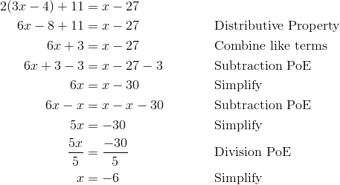

Properties of Equality Review and Additions!!! Reflexive, Symmetric, Transitive are new!!!
