Notes 2.4
Key Concept:
The product of two real numbers of the same sign is positive.
3(4) = 12
(-3)(-4) = 12
The product of two real numbers with different signs is negative.
3(-4) = -12
(-3)(4) = -12
Example: 5(-2)(-5) = (-10)(-5) = 50
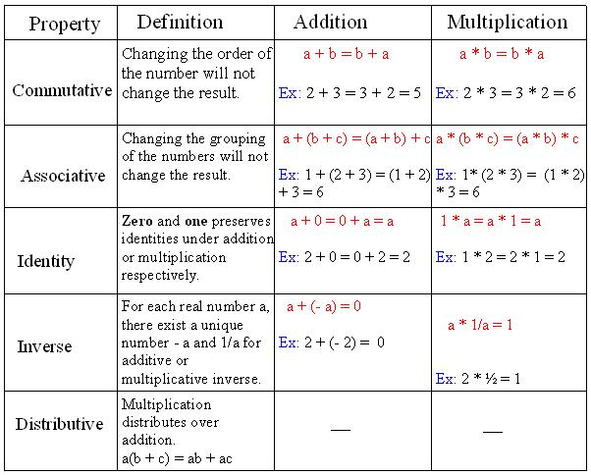
(-0.5)(-4)(-7) = (2)(-7) = -14

Key Concepts:
Property of Zero: The product of a number and 0 is 0.
Algebra: a(0) = 0 Example: 7(0) = 0
Property of -1: The product of a number and -1 is the opposite of the number.
Algebra: a(-1) = -a Example: 8(-1) = -8
Closure Property: A set of numbers is closed under multiplication if the product of any two numbers I the set is also a number in the set.
Example: The set of integers is closed under multiplication because the product of any two integers is an integer.
Vocabulary: Multiplicative identity: The number 1 is called the multiplicative identity when using the identity multiplication property of equality: a(1) = a
Example:
Which property of equality is 6(-1) = -6?
Property of -1
Which property of equality is 9(0) = 0?
Property of Zero
Which property of equality is 2(5) = 5(2)?
Commutative Property
Which property of equality is 3a + 3b = 3(a + b)?
Associative Property
Which property of equality is 4(1) = 4
Identity Property
Which property of equality is 4$\left(\frac{1}{4}\right)=1$?
Inverse Property
Which property of equality is -5(3a + b) = (-5)3a + (– 5)b = -15a – 5b?
Distributive Property
Example:
In 1900 the elevation of Mono Lake in California was about 6416 feet. Approximate the elevation in 2000 given the following information.
- From 1900 to 1950, the average rate of change in elevation was about -0.12 foot per year.
- From 1950 to 2000, the average rate of change in elevation was about -0.526 foot per year.
Step 1: Write a verbal model:
New elevation = Original elevation + (Average rate of change)(time span)
New elevation = 6416 feet + (-0.12$\frac{ft.}{yr.}$)(50yrs.) + (-0.526$\frac{ft.}{yr.}$)(50yrs.)
New elevation = 6416 ft. + (-6 ft.) + (-26.3 ft.) = 6383.7 ft.

