Notes 2.1
Vocabulary:
Natural or Counting Numbers: 1, 2, 3, 4, …
Whole numbers: 0, 1, 2, 3, …
Integers: …, -2, -1, 0, 1, 2, ….
Rational Numbers: Integers and anything that can be written as a fraction without a 0 in the denominator ($\frac{3}{4})$, and repeating or terminating decimals (0.123, 0.12121212….).
Irrational Numbers: square roots or other roots ($\sqrt{2},∛13)$, nonterminating decimals ( 0.12345678…), e, π
Real Numbers: All of these numbers
Example 1: Graph and compare integers
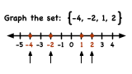
Example 2: What is not a rational number?
- $\frac{1}{2}$ b. 0.8888…. c. 0.356298…. d. -4
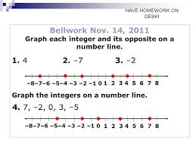
Example 3:

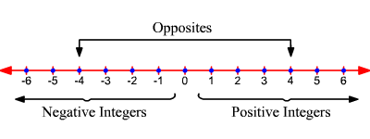
Opposite Numbers:

Example 4: What is the opposite if a = -4.7?
4.7
What is the opposite if a = $-\frac{2}{5}$ ?
$\frac{2}{5}$
Absolute Value: 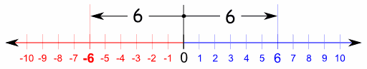
Example: |121| = 121, |-121| = 121 Absolute value signs are like a laundry machine. Think of a negative sign as dirt!
Conditional Statement: (If-then statements)---it has a hypothesis and a conclusion.
If I go out in the rain, then I will get wet.
Hypothesis Conclusion

Counterexamples: If a conditional statement has one false example of the conclusion, then it’s false.
What if I’m wearing water proof rain gear? I won’t get wet, but my rain gear will.

