Bottle Rocket Instructions
Yearly results posted here
The Two Challenges are:  Note. A student can create two separate rockets for both challenges, but only one rocket will be accepted on the day of the challenge. | A - To keep the rocket in the air for a maximum period of time.  B - To make the rocket reach the greatest height possible.
When: | Last week of School in June

What is a bottle rocket and what does it have to do with science?
A bottle rocket is a 2-liter (soda) bottle with compressed air and water released in an upward direction. It has everything to do with science because we can use this tool to learn many concepts about motion, forces, energy and flight as well as the scientific method.

Why do bottle rockets fly?
The air pressure propels the bottle rocket skyward.

Preliminary Questions to consider:
-Why do we have to use water, or do we?
-If a little water works well, will a lot of water work better?
-Will it fly best when it is totally full?
-What volume of water works best?
-Will it fly without water?

Why did the rocket that was full of water barely take off?
It was too heavy or massive. This can be explained with Newton's first law of motion: A body at rest tends to remain at rest and a body in motion tends to stay in motion.

The rocket didn't have enough "oomph" (force) to make it take off. Why?
There was not enough force for the relatively huge mass. The more mass it has, the less it will accelerate using the same force. This can be explained using Newton's second law of motion: Force equals Mass times Acceleration.

Why did the water go one-way and the rocket the other?
There is an equal force in both directions. This can be explained by Newton's third law of motion: For every action there is an equal but opposite reaction.

Design Ideas:
Fins:
-Fins should be firm; If they flop around they are useless.
-Fins should be adequately secured; duct tape works well.
-The best fins have been made of rigid cardboard such as a manila folder.
-The size of the fin does matter! Remember the paper airplane challenge in which we created planes to fly a maximum distance? In that lab the best planes had long and narrow fins.
Parachute:
A garbage bag parachute will do the trick
Cut the bag, lay it flat
Attach strings in the manner indicated in the following picture
I would suggest that you use 16 strings.
Attach the parachute to the inside of the sleeve, underneath the nose cone as the following diagram indicates.
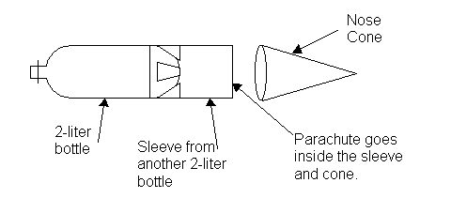

Use the "Z" fold, do not wrap the strings around the parachute. 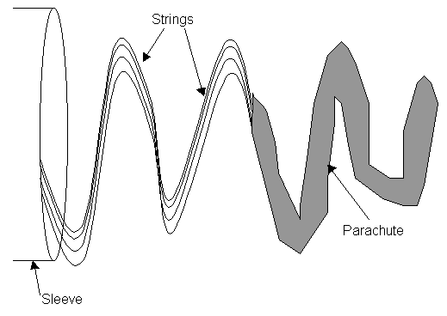
Nose Cone:
How do you get the nose cone to separate from the rocket body?
Inertia is a property of matter. The more matter (mass) something has the more inertia it will have. Therefore, we must add some mass to our nosecone.
The nose cone must have a higher mass to surface area ratio than the body of the rocket. The nose cone must go through the air easier than the body of the rocket.
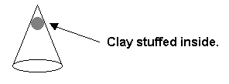
Once the nose cone separates it must remain linked to the body of the rocket.
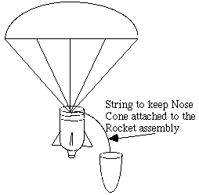
PROCEDURE:
Background: Students will build a rocket made from a typical 2-liter soda bottle. The opening of the bottle must be the normal sized opening (9/16" inside diameter). The bottle will be turned so that the opening is down and will expel water and air downward, thus pushing the bottle upward.

The rocket must be made to fit the following parameters:
- Students will bring one completed 2-liter bottle rocket to school. No commercially finished or model products may be used. Students should place their name.
- The pressurized portion of the rocket must consist of one plastic 2-liter pop bottle. The manufactured structural integrity of the bottle cannot be altered. In other words, Don't poke a hole in the bottle!!! No metal parts will be allowed on the pressurized rocket body. The mass of the empty rocket assembly cannot exceed 300 grams.
- All energy imparted to the rocket must originate from the water/air pressure combination. No other potential or kinetic source of energy will be permitted.
- All rockets will be launched at a pressure not to exceed 60 pounds per square inch. Once the rocket is pressurized, no student can touch or approach the rocket.
- Each rocket launched must pass a safety inspection and have a mass measurement taken.
- Though various rocket components may separate during the flight, all must remain linked together with a maximum distance not to exceed three (3) meters. If a nose cone is used, it can separate, but should remain attached to the rocket body. If the any part of the rocket becomes unattached during flight, the rocket will be marked as a detachment and will be disqualified.
- Caution: No materials will be allowed that can compromise the integrity of the plastic bottles (e.g., hot glues or super glues). Cold glue is acceptable. Sanding or other abrasion of the plastic used for the pressurized body is not allowable. Use of duct tape is highly recommended as the main type of fastener.

SCORING: There will be one actual launch per student. All rockets will be launched using the launching pad provided by Mr. Rehak. The judge will time the rocket's flight. Timing of the rocket starts when the rocket leaves the launch pad, and stops when the first part of the rocket hits the ground, when the rocket disappears from the judges' sight, or when the rocket impacts or gets entangled in an object (e.g. the rocket collides with a tree.)

The winning rocket will be determined by the greatest time aloft (recorded to the nearest tenth of a second).

The second winning rocket will be the one that reaches the highest altitude.

Good luck and happy flying!

Source http://hometown.aol.com/hayhurst1/h2orocket.htm

