TI-84 CALCULATOR INSTRUCTIONS – STATISTICS

**AREA**

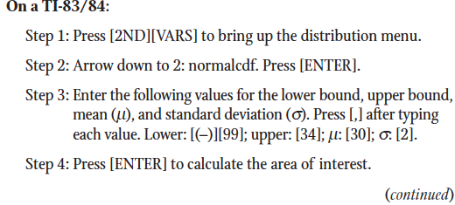



**Read a Table**

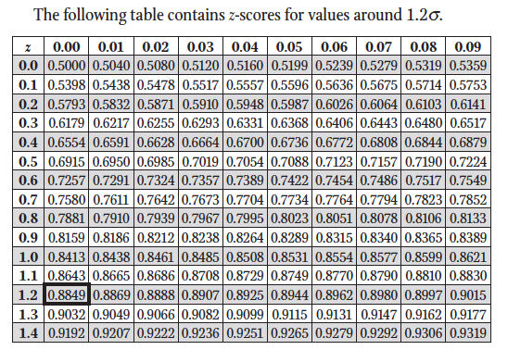

**Z-SCORE**



