Notes 2.7
Square Root of a Real Number
Words: A square root of a real number a is a real number b such that b² = a.
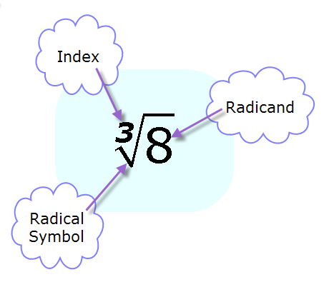
Example: 4² = 16 and (-4)² = 16, so 4 and -4 are the square roots of 16.

When we use square roots with a radical sign, we usually don’t write the index of 2. It is understood that the square root has an index of 2. Other indexes are written.

Example: Evaluate
- $\sqrt{36}=6$
- $-\sqrt{64}=\left(-1\right)\sqrt{64}= -8$
- $±\sqrt{81}= ±9$

Approximate a square root: If the square root is not an integer, you can approximate it by finding what integers it’s between.
Example: Approximate the square root of $\sqrt{31}$
$\sqrt{25}<\sqrt{31}<\sqrt{36}$
$5<\sqrt{31}<6$
$\sqrt{31}$is about halfway between the two integers, so $\sqrt{31}≈5.6$, since it’s a little more closer to 36 than 25. If we were to approximate it to the nearest integer then:
$$\sqrt{31}≈6$$
Vocabulary: The square root of a whole number that is not a perfect square is an irrational number.
Just as a reminder, look at the chart below:
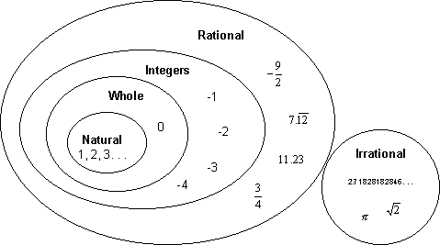

Next, remember if-then statements? Rewrite:
- No counting numbers are irrational.
If a number is a counting number, then it is not an irrational number.
True
- Real numbers are rational numbers.
If a number is a real number, then it is a rational number.
False. Irrational numbers are real numbers, too.

