Notes 2.5

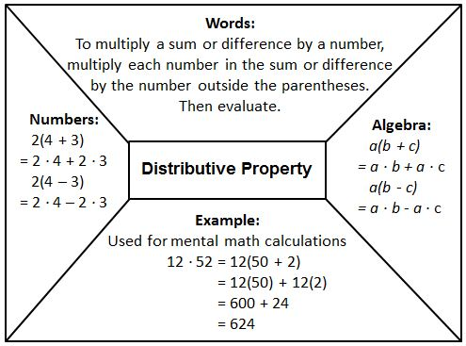

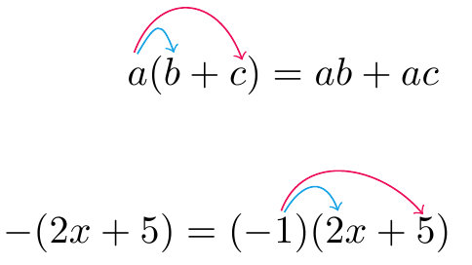
Example: -7(3a + b) = (-7)3a + (– 7)b = -21a – 7b

Vocabulary:
Terms: the parts of an expression that are added together
Coefficient: The number part of a term with a variable part
Like Terms: terms that have identical variable parts with the variable parts raised to the same power (same exponent).
Constant Term: a term that has no variable part. Constant terms are also like terms since their variable has the power of 0 (exponent of 0).
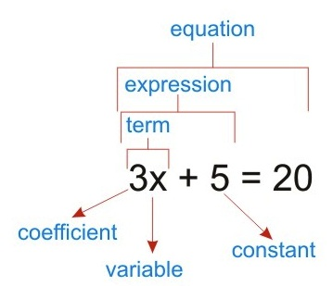

Identify the terms of -3x + 8 + 4x – 1
Terms: -3x, 8, 4x, -1
Like Terms: -3x and 4x,
8 and -1
Coefficients: -3, 4
Constants: 8, -1
Example: Simplify the expression 6(x – 2) – 4(3 – x)
6x + 6(-2) + (-4)3 + (-4)(-x)
6x + (-12) + (-12) + 4x
6x + 4x + (-12) + (-12)
10x + (-24)
10x – 24
Example: Your daily workout plan involves a total of 50 minutes of running and swimming. You burn 15 calories per minute when running and 9 calories per minute when swimming. Let r be your running time (in minutes). Find the number of calories you burn in your 50 minute workout if you run for 20 minutes.
Step 1: Verbal Model
Amount burned =
(Burning rate when running)(running time) + (burning rate when swimming)(swimming time)
C = 15r + 9(50 - r)
C = 15r + 450 – 9r
C = 15r – 9r + 450
C = 6r + 450 where r = 20 minutes
C = 6(20) + 450
C = 120 + 450
C = 570 calories

