Notes: 2.2
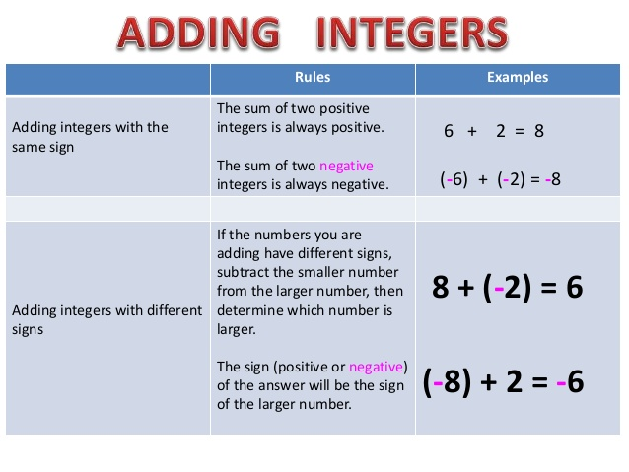
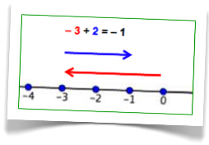
3 + 4 = 7
-3 + -4 = (-1)(3 + 4) = (-1)(7) = -7
Same Signs Sum
-3 – 4 = (-1)(3 + 4) = (-1)(7) = -7
4 – 3 = 1
4 + -3 = 1
Different Signs Take the Difference and Keep the Sign of the Bigger Number
-3 + 4 = 4 – 3 = 1
3 + -4 = (-1)(4 – 3) = (-1)(1) = -1
-4 + 3 = (-1)(4 – 3) = (-1)(1) = -1
3 – 4 = (-1)(4 – 3) = (-1)(1) = -1
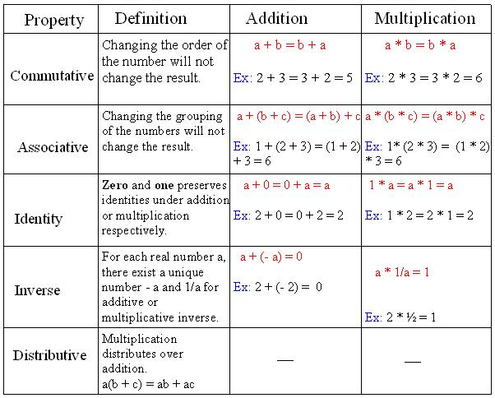
Closure Property: A set of numbers is closed under addition if the sum of any two whole numbers in the set is also a number in the set.
Example 1: The set of whole numbers is closed under addition because the sum of any two whole numbers is a whole number.
The identity property states that the sum of a number a and 0 is a. The number 0 is the additive identity. The inverse property states that the sum of a number a and its opposite is 0. The opposite of a is also called the additive inverse of a.
Example 2: What property is this?
- a + (b + c) = (a + b) + c
Associative
- 9 + 0 = 9
Identity
- 8 + (-8) = 0
Inverse
- 3 + 5 = 5 + 3
Commutative

